Pengshengnan Cheng V00838497 Assignment3

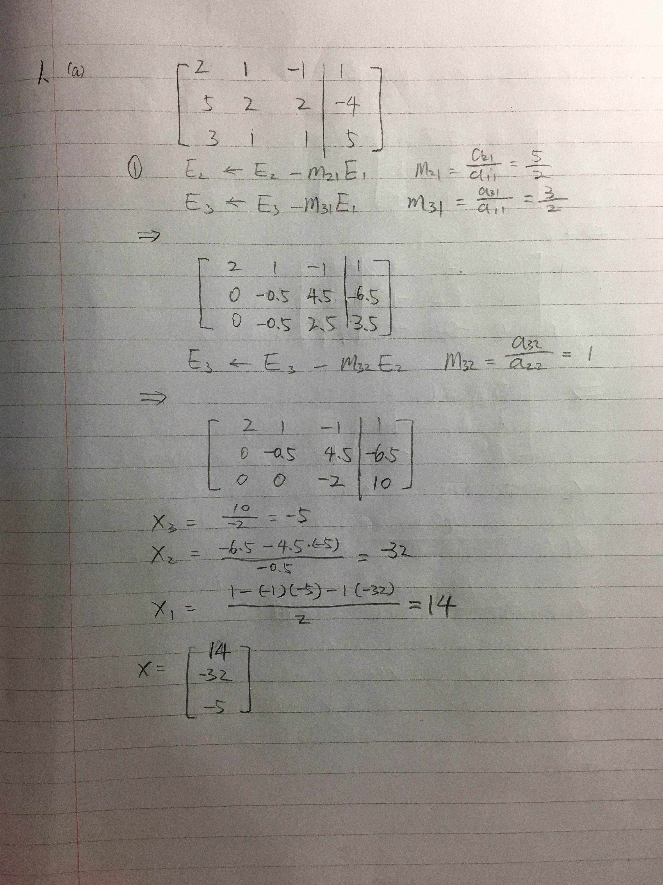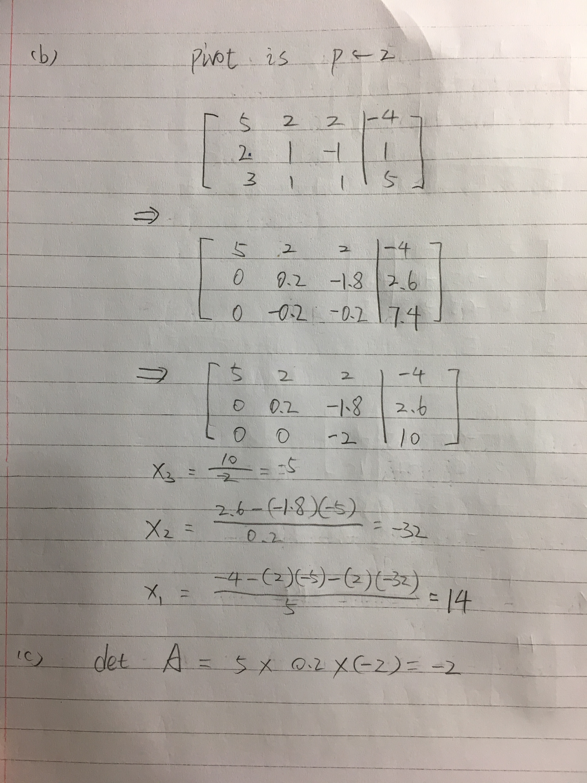

(b)

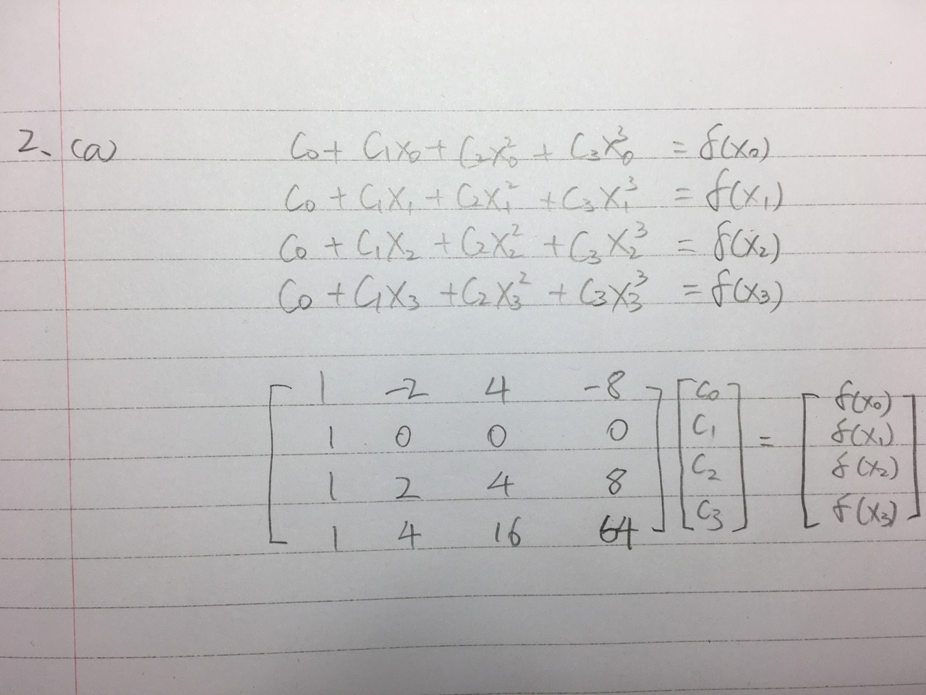

>> A = [1,-2,4,-8;1,0,0,0;1,2,4,8;1,4,16,64]

A =

1 -2 4 -8

1 0 0 0

1 2 4 8

1 4 16 64

>> B = [sinh(cos(-2));sinh(cos(0));sinh(cos(2));sinh(cos(4))]

B =

-0.4283

1.1752

-0.4283

-0.7012

>> X=A\B

X =

1.1752

-0.3781

-0.4009

0.0945

C0 = 1.1752; C1 = -0.3781; C2 = -0.4009; C3 = 0.0945

(C)

>> fplot(@(x)sinh(cos(x)),[-2,4])

>>hold on

>> fplot(@(x)1.1752-0.3781\*x-0.4009\*x.^2+0.0945\*x.^3,[-2,4])



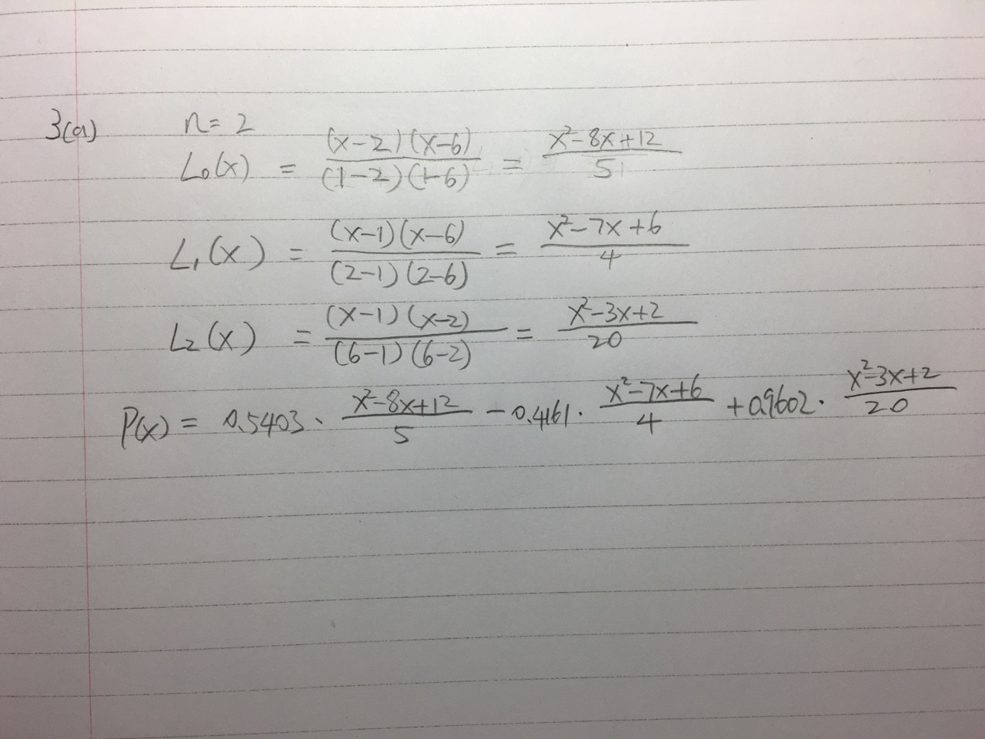

(b)

>> x = 0:0.1:8;

>> hold on

>> plot(1,0.5403,'\*')

>> plot(2,-0.4161,'\*')

>> plot(6,0.9602,'\*')

>> plot(x,cos(x)) 

(c)

L0(x)f(x0) = 0.5403 \* (x.^2-8\*x+12)/5;

>> fplot(@(x)0.5403 \* (x.^2-8\*x+12)/5,[0,8])



L1(x)f(x1) = 0.4161\* (x.^2-7\*x+6)/4

>> fplot(@(x)0.4161\* (x.^2-7\*x+6)/4,[0,8])



L2(x)f(x2) = 0.9602\*(x.^2-3\*x+2)/20

>> fplot(@(x)0.9602\*(x.^2-3\*x+2)/20,[0,8]) 

(d)

>>hold on

>> l0 = 0.5403 \* (x.^2-8\*x+12)/5;

>> l1 = 0.4161\* (x.^2-7\*x+6)/4;

>> l2 = 0.9602\*(x.^2-3\*x+2)/20;

>> plot(1,0.5403,'\*')

>> plot(2,-0.4161,'\*')

>> plot(6,0.9602,'\*')

>> sum = l0+l1+l2;

>> plot(x,sum)

>> plot(x,cos(x))

